**Experiment-2**

Name of Student: Abhishek Bhadre

Division: ICA-B1 Roll No: 21

**Title:** Generation of Signals & Signal Operations

**Objectives:**

* To study the theory of Signal and signal generation
* To perform the operations on signals

**Outcomes:** After completion of the experiment students will be able

* To observe the generated signal and the operations performed on signals.
* To understand the process of signal operation and its implementation.

**Signal Generations:**

Signals and systems are abstract concepts of a wide variety of physical variables and processes in various fields in engineering and sciences.

**Representation and attributes of signals:**

* **Signal as a function of time/space**

Most signals of interest in practice are recorded values of a physical quantity, represented as a 1-D functions, such a time function $x(t)$ or 2-D/3-D functions, such as a spatial function $f(x,y)$  or $f(x,y,z)$ . Examples of signals include as temperature over time or space, sound (speech, music, etc) over time, images over space, etc. A signal carries information and contains energy.

* **Different types of signals:**

*Analog signal*: a function $x(t)$  , continuous in amplitude, of a continuous independent variable $t$  (e.g., time).

*Discrete signal*: A function $x\left[n\right]=x({nt}_{0})$, continuous in amplitude, but defined only at a set of discrete values of the independent variable,

$t=0,±t_{0}, ±2t_{0, . . .}$ .

Digital signal*:* A discrete signal with quantized (finite) amplitude values. For example, there are $2^{8}=256$  grey scale levels in an 8-bit digital image.

Periodic signals*:* A continuous signal $x_{T}\left(t\right)=x_{T}(t+T)$  is periodic with period $T$, a discrete signal $x\left[n+N\right]=x[n]$  is periodic with period $N$.

When   or $N→∞$ , the $x(t)$  or $x[n]$  becomes non-periodic.

Random signals: A signal $x\left(t\right)$  or $x[n]$  can be random. If an experiment is carried out repeatedly, the outcomes may not be identical. For example, the annual temperature profile varies year by year. Such a random time function is called a random process.

Energy and power signals: From physics, a variable squared is usually related to power or energy. For example, $v^{2}(t)/R$  and $i^{2}(t)/R$  are powers in the electrical systems, and $mv^{2}(t)/2$ , $kx^{2}(t)/2$  are the kinetic and potential energy in mechanical systems.

**Procedure: Basic Signal Generation**

1. Clear the work space, close all the open windows and clear the command window.
2. Initialize the pointer to mark the signal value in signal plot.
3. Plot Impulse signal as $δ\left(n\right)=\left\{\begin{aligned}1 if n=0 \\ 0 if n≠0\end{aligned}\right.$
4. Plot Unit step signal as $u\left(n\right)=\left\{\begin{aligned}1 if n>=0 \\ 0 if n< 0\end{aligned}\right.$
5. Plot Unit ramp signal as $r\left(n\right)=\left\{\begin{aligned}n if n>=0 \\ 0 if n< 0\end{aligned}\right.$
6. Plot exponential signal as $E\left(n\right)=\left\{\begin{aligned}e^{n} if n>=0 \\ 0 if n< 0\end{aligned}\right.$
7. Plot Square wave signal as $S\left(n\right)=\left\{\begin{aligned}1 if nis even \\ 0 if n is odd \end{aligned}\right.$
8. Plot Sine wave signal as $x\left(n\right)=Asin(wt+∅)$
9. Also observe and draw output waveform for above defined signals and see the spectrum**.**

**I/P & O/P Waveforms:** To be drawn by students

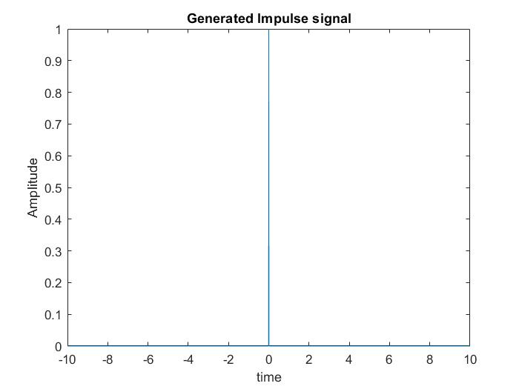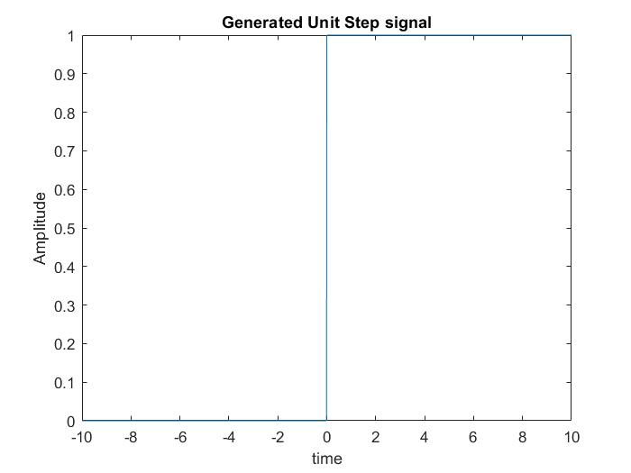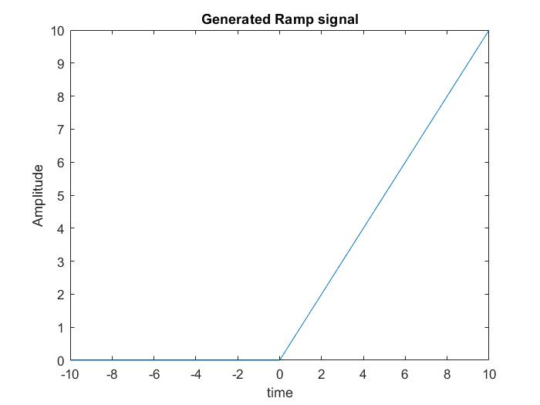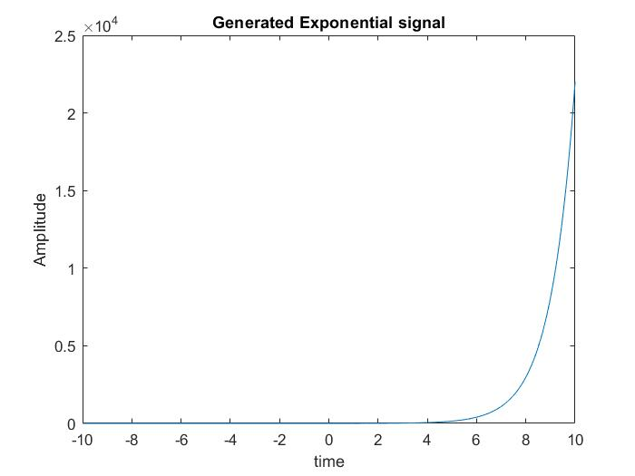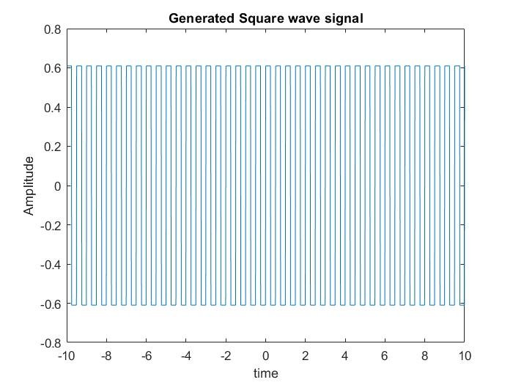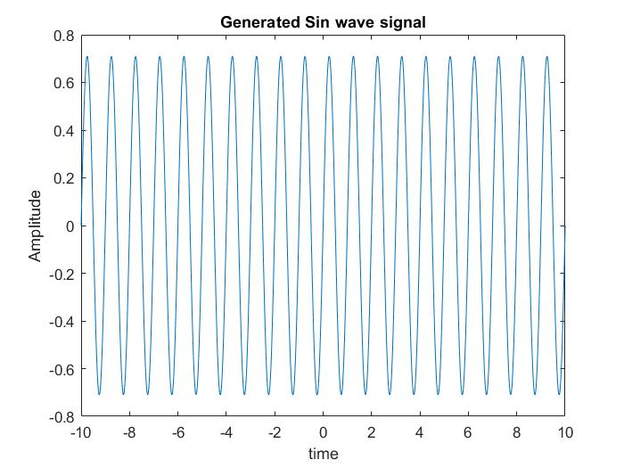

**Procedure: Signal operation**

1. Clear the work space, close all the open windows and clear the command window.
2. Initialize the pointer to mark the signal value in signal plot.
3. Generate the tow signals x1(n) and X2(n)
4. Plot signal Addition as y(n)=x1(n)+x2(n)
5. Plot signal Subtraction as y(n)=x1(n)-x2(n)
6. Define signal Multiplication as y(n)=x1(n)*x2(n)
7. Plot signal for amplitude Scaling as y(n)=Ax1(n)
8. Plot signal for time delay as y(n)=x1(n-k)
9. Plot signal for time scaling as y(n)=x1(A*n)
10. Also observe and draw output waveform for above defined signals**.**

**I/P & O/P Waveforms:** To be drawn by students

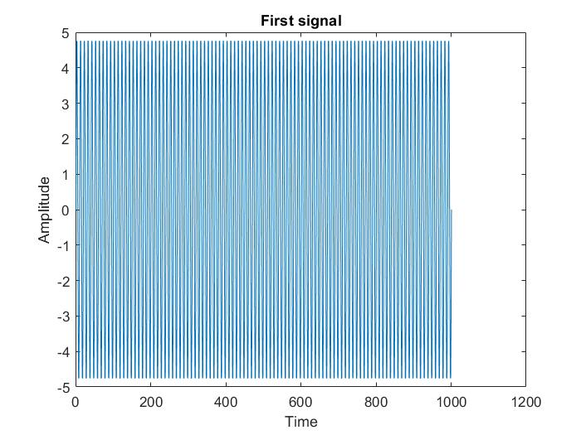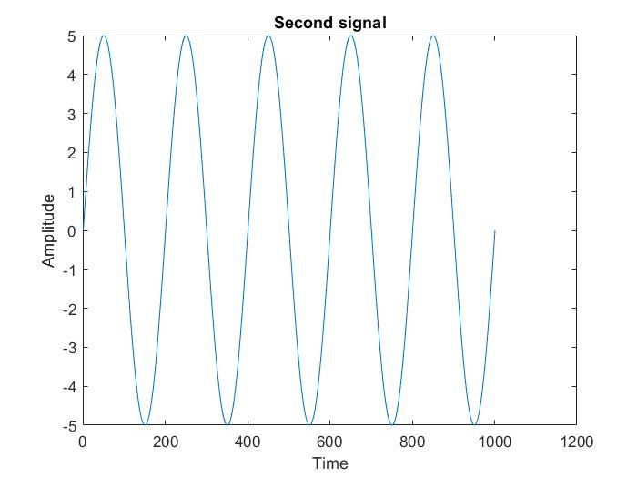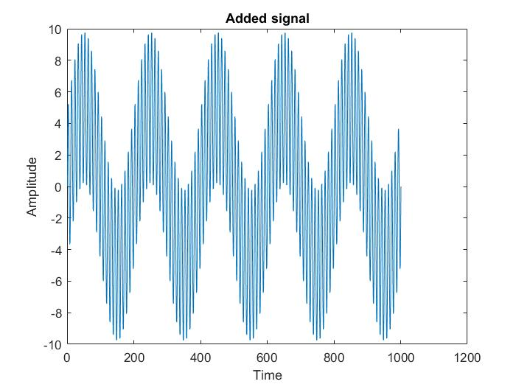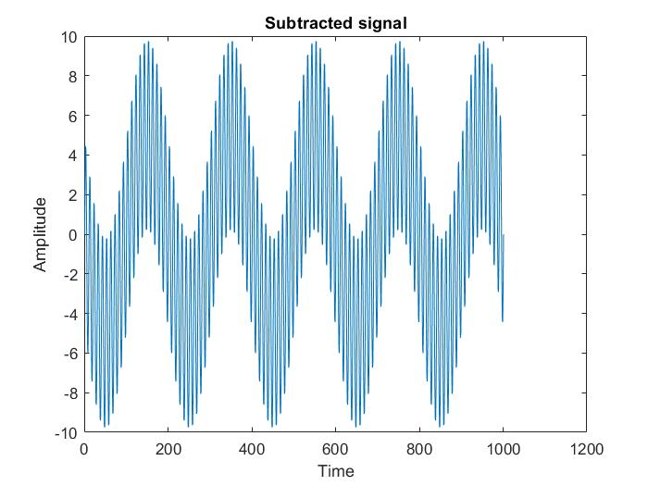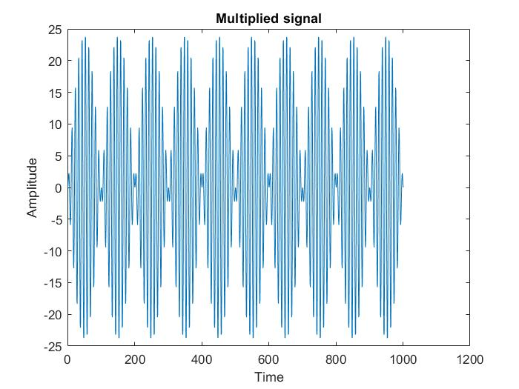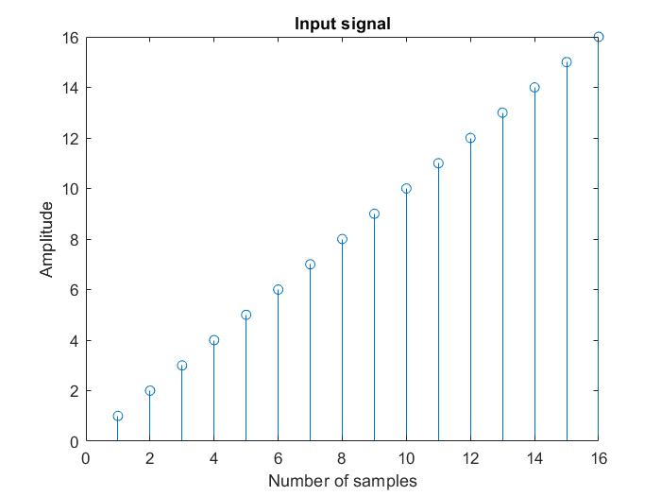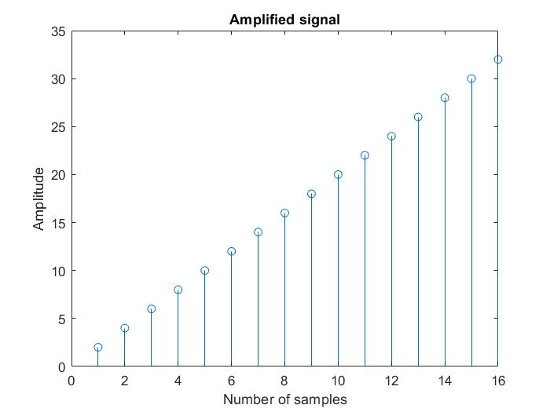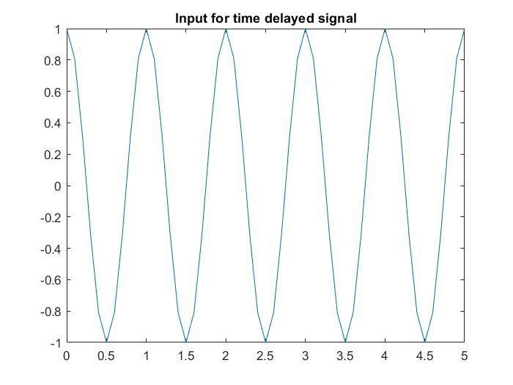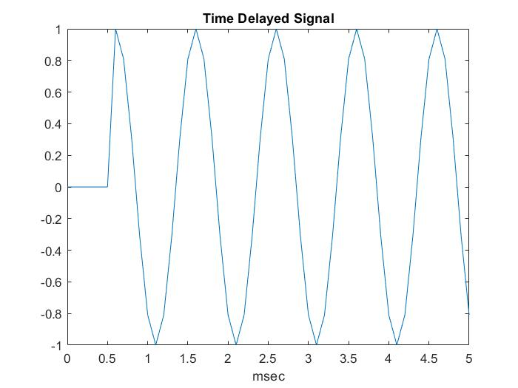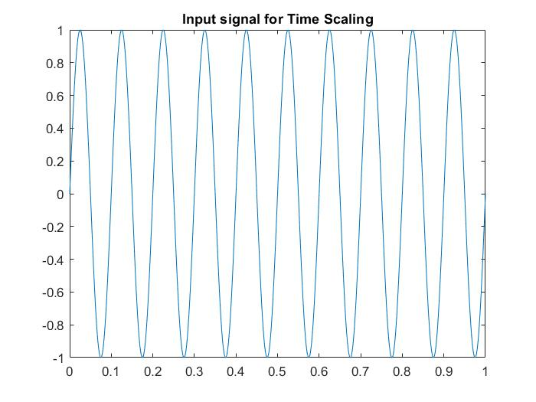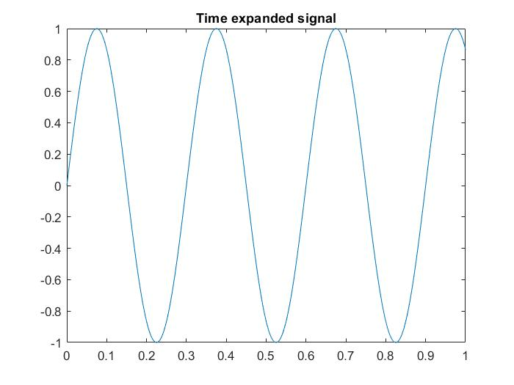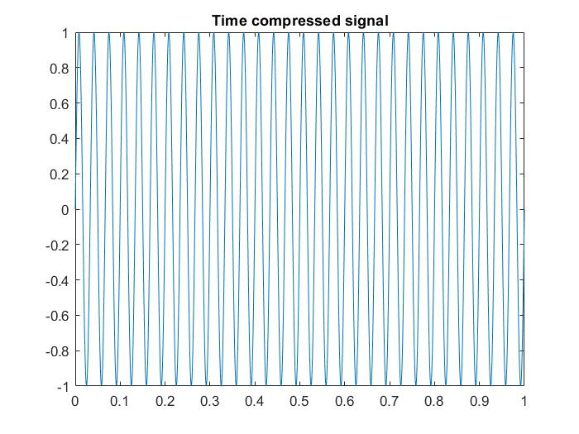

**Conclusion:**

1. Signal generation allows us to perform and create various operations on signals. They help in solving solutions in various fields. They allow operation like addition, subtraction, multiplication, time delay and time scaling.
2. We can decide any function for any particular signal. This includes trigonometric functions, exponential functions etc.
3. By using subplots, we can arrange many signals as per our requirement in a single screen that would make the comparison of graphs further easy.